Practice challenge
LO2 – Advising
Malamski,Dimitar D.S.
mitemalamata@gmail.com

Contents
Introduction 2
Sprints 2
Sprint 1 2
Sprint 2 2
Evidence 2 - Recommending suitable indicators for the target variable 3
Evidence 3 - Recommending an analytical approach suitable for early intervention 4
Evidence 4 - Recommending a sustainable and responsible AI approach 5

Introduction
This document presents the evidence for Learning Outcome 2 ( Advising ) in my Practice Challenge project - Student Dropout Prediction. The purpose of this document is to show how I demonstrated this learning outcome by translating the results of my analysis and experiments into practical recommendations. The evidence is organized by sprint, with each section describing the activity, the result, and why it is relevant to the learning outcome.

Sprints

Sprint 1
There was no progress made relating to Advising during Sprint 1.

Sprint 2
Evidence 1 - Recommending the target variable and prediction setup
What this evidence is
This evidence shows how I recommended an analytical approach by defining the target variable and the nature of the prediction task.
What I did
I examined the target variable and found that the dataset originally contained three categories: Dropout, Enrolled, and Graduate. I analyzed the meaning of the Enrolled category and concluded that these students did not yet have a final academic outcome. Because they could later either graduate or drop out, including them in the training data would reduce the reliability of the prediction task. Based on this, I redefined the task as a binary classification problem using only students with known final outcomes.
Result
This created a clearer and more reliable analytical approach for the project. The target variable became more suitable for prediction, and the modelling setup better matched the project context.
Why this is relevant to the Learning Outcome
This demonstrates advising because I recommended how the target variable should be defined in order to create a more meaningful and reliable AI solution for the given problem.
Attached evidence
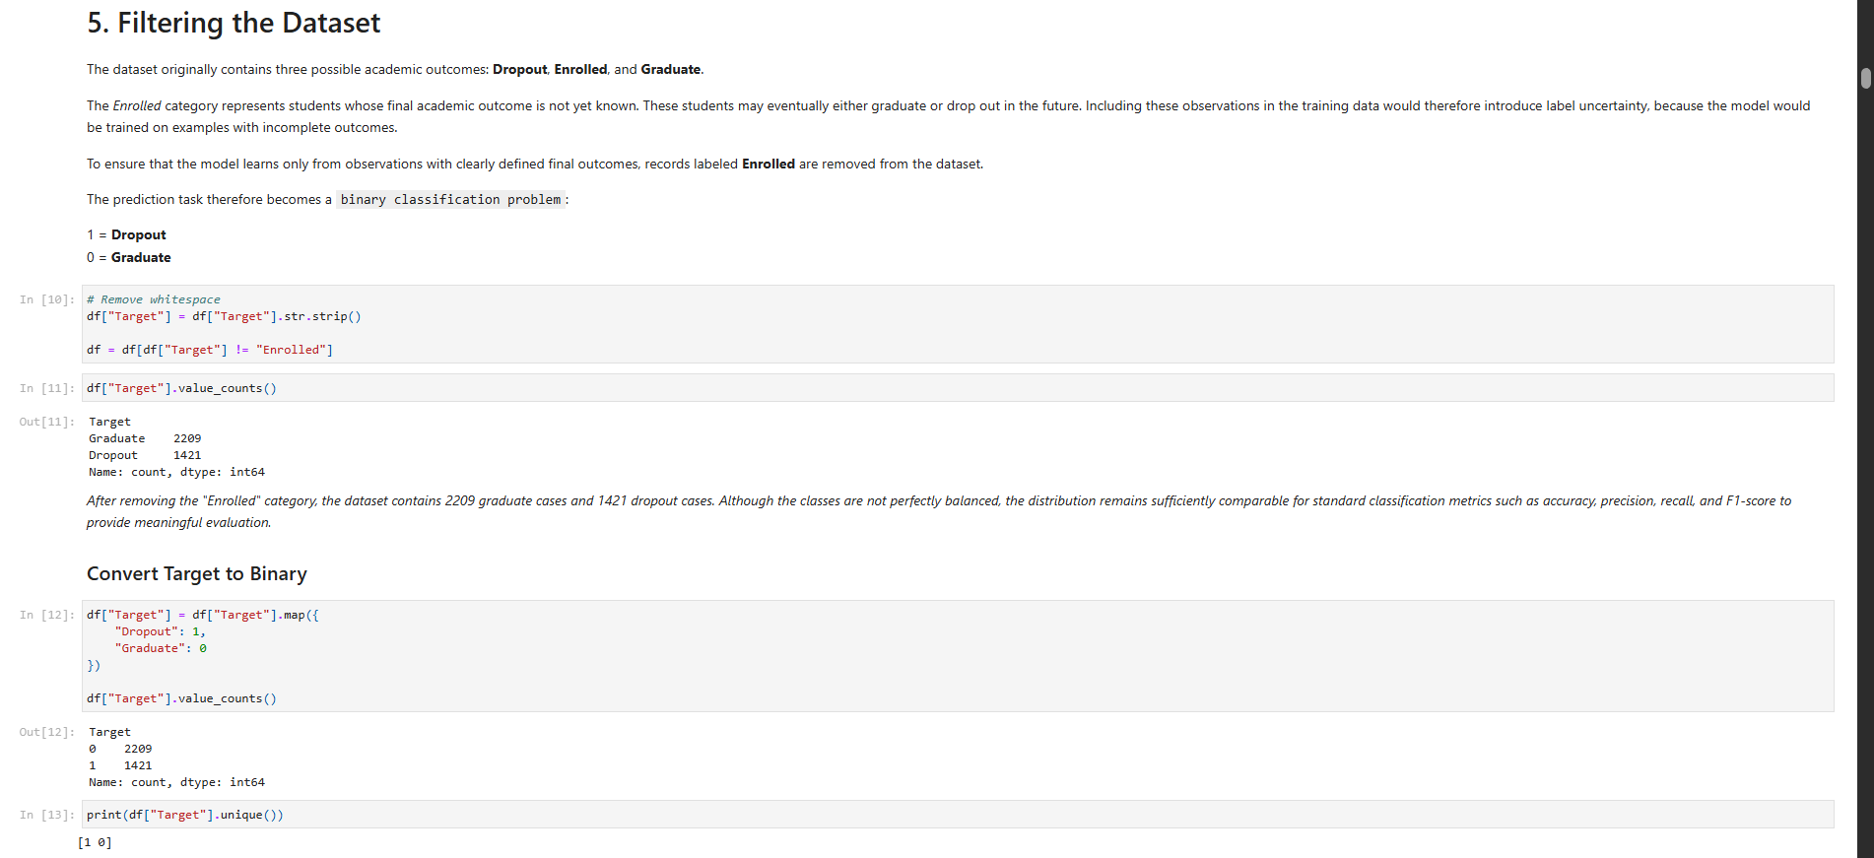

Evidence 2 - Recommending suitable indicators for the target variable
What this evidence is
This evidence shows how I identified which features were the most suitable indicators for predicting the chosen target variable.
What I did
I used analytical insights from correlation analysis and visual exploration to determine which variables were most strongly related to student dropout. Through this process, I found that academic performance indicators such as first-semester grades and approved curricular units had the strongest relationships with the target. Financial and administrative variables such as tuition fee status and scholarship holder status were also meaningful indicators.
Result
This allowed me to recommend that the analytical approach should focus primarily on early academic and financial indicators when predicting dropout risk.
Why this is relevant to the Learning Outcome
This demonstrates advising because I used analytical insights to recommend which features are most suitable as indicators for the target variable in the given problem context.
Attached evidence
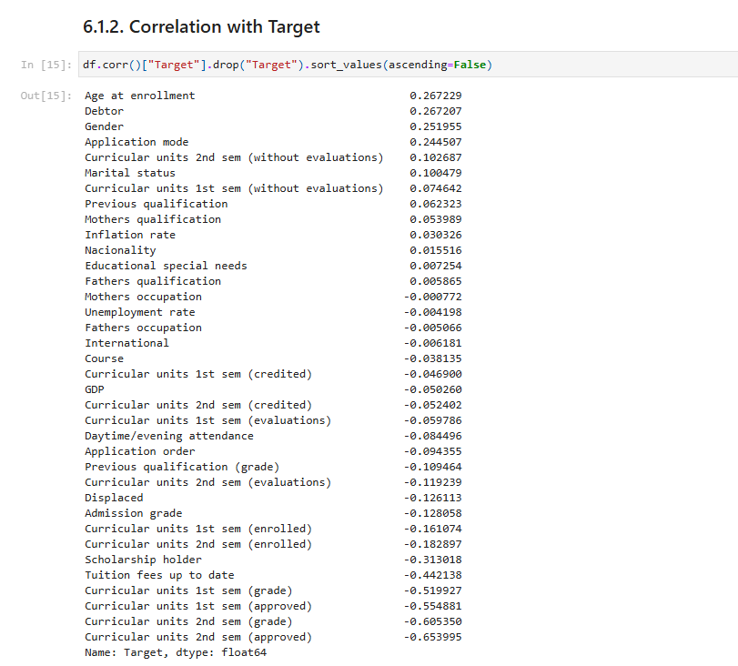

Evidence 3 - Recommending an analytical approach suitable for early intervention
What this evidence is
This evidence shows how I recommended an analytical approach that fits the practical context of early student intervention.
What I did
During the analysis, I observed that several second-semester academic variables had strong predictive relationships with dropout. I then considered whether these features would realistically be available at the time an early dropout prediction should be made. Since the purpose of the project was to support early intervention, I concluded that second-semester variables would introduce data leakage and make the analytical approach unsuitable for the real use case.
Result
This led to the recommendation that the analytical approach should only use variables that are available early enough to support timely intervention. As a result, second-semester curricular unit features were excluded from the model input.
Why this is relevant to the Learning Outcome
This demonstrates advising because I recommended an analytical approach that fits both the prediction problem and its real-world context, rather than simply selecting the most predictive variables.
Attached evidence
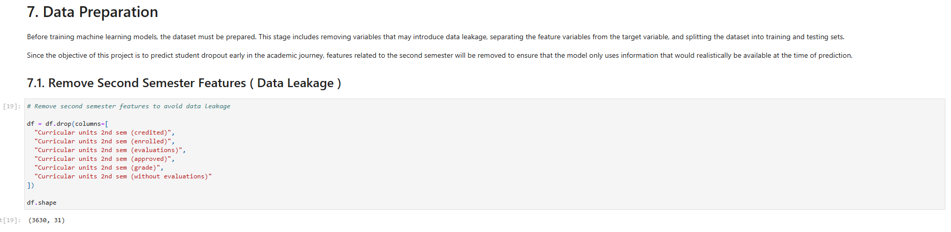

Evidence 4 - Recommending a sustainable and responsible AI approach
What this evidence is
This evidence shows how I used sustainable AI principles to advise on responsible feature use in the prediction system.
What I did
I identified potentially sensitive features, including Gender, Nacionality, Mothers qualification, Fathers qualification, Mothers occupation, and Fathers occupation. I analyzed their distributions and dropout rates across groups, and considered their ethical implications using the principles of fairness and the EU Ethics Guidelines for Trustworthy AI. I then compared the original models with ethical versions trained without these features.
Result
The comparison showed that strong predictive performance could still be achieved without relying on sensitive demographic and socioeconomic variables. Based on this, I recommended avoiding these features where possible in order to support a more responsible and sustainable AI solution.
Why this is relevant to the Learning Outcome
This demonstrates advising because I grounded my recommendation in both analytical findings and sustainable AI frameworks, rather than only focusing on predictive performance.
Attached evidence
